**MINI PROJECT – I**

**(2020-21)**



**Institute of Engineering & Technology**

**PROJECT REPORT**

**IOT ENABLED WI-FI ROBOTIC CAR**

**Submitted By: Submitted To:**

**Tej Pratap Singh (171500358) Mr. Amir Khan**

**Satyam Singh (171500296) Technical Trainer**

**Branch/Sec: B.tech (Computer Science) -IIIrdYear-I**

**Contents**

**Abstract 3**

**Table of Contents**

1. **Introduction 4-10**
   1. General Introduction to the topic 04
   2. Purpose of Plan 05
   3. Project Objective 06
   4. Project Goal 06
   5. Scope Definition 06
   6. Existing System 07
   7. Functional Specification 08
2. **Work 10-14**
   1. Working 10
   2. Circuit 11
3. **Use of Project 15**
4. **Screenshot 16**
5. **Source Code 20**
6. **Conclusion 25**

**Abstract**

The project aims are to design an android interface, Wi-Fi robotic car and write program in to the Arduino. Robotic car contains Node MCU with basic mobility features. Arduino programs contains instructions mediating between android control and Robotic car. Android mobile controller uses different mobile sensor to supervise motion.

An appropriate program in the Node MCU microprocessor to interact with the android controller has to be created. The program has been successfully complied through arduino IDE to the Node MCU microprocessor & loaded in to it after proper checking of logic to decrease any loss/damage of hardware.

We have to create an android application that will provide user an interface to interact with the wi-fi robotic car. The interface is easy to use provide feedback from the Node MCU microprocessor through the wi-fi after giving instruction to Node MCU for various actions through interface via wi-fi module (ESP8266). The android application is to create with the help of android studio or blink app that provide us with more capability & stability.

* 1. **General Introduction to the topic**

Internet of Things (IOT) is a new revolution of the internet. It enables to connect remote and mobile things or machine or assets through the use of wireless communication and low-cost sensors, computing and storage devices.

This project shows how to use internet of things (IOT) for controlling Robotic car remotely (anywhere), provide that your robot is connected to the internet.

Robots can be controlled wirelessly by various means like Bluetooth, Wi-Fi, etc. We will make a Wi-Fi controlled Robot car Using Node MCU which can be controlled wirelessly by using internet browser.

In the present day, technology has no improved that an Unmanned Aerial Vehicle (UAV) also called as Drone can be Controlled from a distance ranging from 2km to 20,000km. The Mars Rover, which was sent to mars to explore various feature of the planet is an autonomous robot which is programmed such that it performs the desired task as it intended to do. There are many such systems which are controlled either by radio frequency transmission or by creating intelligence. Robots are called Non-autonomous robots. These robots have the programming logic to do the desired task but the decision power lies in the hand of controller (human) handing the robot.

Here the interface can be made using two methods:

A. Wired –The connection between controller and robot is maintained using wired interface. This interface can be serial or parallel but the technology is transmission of signal, which is sent in the form of specific pattern to the robot to carry out the specific task, these patterns with the help of a microcontroller governing its motion.

B. Wireless –Here the connection between controller and robot is achieved by wireless interface such as:

->Bluetooth  
 ->Wi-Fi

Arduino is designed as open-source electronics prototyping platform providing schematics and flexible development kits for enthusiastic users who intend to produce interactive objects or environments. Arduino can be used to sense surroundings by utilizing various transducers to read and interpret inputs in order to make responses for example through the controlling of motors or transferring of data. In today’s world there is a significant development in the field of robotic control. Mobile robotic vehicles are light, small and portable enough to be carried by an individual.

* 1. **Purpose of Plan**

As most of the work in this area has been done regarding the Node MCU & its application, what left out most of the time is the Android controller. In this project we are trying to exploit the android open accessory Bundle so that we can give

a) More realistic experience to the user.

b) Better Connectivity to the Node MCU Chip.

c) Increasing the efficiency in controlling of Bot.

* 1. **Project objectives**

In this project we will be constructing the android guided Robotic Car by extracting the powers of both the open source technologies- Android and Arduino Programming.

**1.4 Project goals**

* To develop an android application that will provide user an interface to interact with the Arduino powered car.
* To develop an appropriate program in the Arduino microchip to interact with the android controller.
* To compile all the developed modules that we constructed above.
* To produce Arduino car that is controlled by android phone remote which can be used in various fields, like defence, scientific expeditions and so on.

**1.5 Scope Definition**

The project is limited to designing an android interface, Node MCU bot and write program in to the Node MCU microprocessor. Node MCU car contains Node MCU microcontroller with basic mobility features. Arduino programs contains instructions mediating between Node MCU controller and Node MCU car. Android mobile controller uses different mobile sensors to supervise motion.

**1.6 EXISTING SYSTEM**

Existing System Existing system is implemented using the Node MCU board. In this project user can controller the devices from the switching system remotely. Existing system contain the two sections one is transmitter section another is receiver section. Transmitter section contain the keypad enable Node MCU system and receiver section contain the robot with Node MCU board. Node MCU device is connected with the RF module for transmission of the information between the transmitting Node MCU system and receiving robot section for wireless communication. Power supply section is providing the power to the Node MCU board as well as all the electronic circuit of the receiver section for operate the all device properly.

Now a day the advancement in technology various new designed smart makes use of Wi-Fi robot for various applications. Mostly wi-fi network was using home security purpose. The various applications are done by robot car like doing different works on the command ex- switching on the lights when the robot is given the command by the Wi-Fi enabled device.

Working of the Wi-Fi controlled robot is very easy, we just need to Drag or Slide the joystick in the direction, where we want to move the Robot. If we want to move the Robot in Forward direction then we need to Drag the Joystick ‘circle’ in Forward

direction. Like we can move the Robot in Left, Right and Backward direction by Dragging the Joystick in respective direction.

Now as soon as we release the Joystick, it will come back to centre and Robot. Blynk App sends values from Two Axis Joystick to Node MCU. Node MCU receive the values, compare them with predefined values and move the robot accordingly in that direction

**1.7 FUNCTIONAL SPECIFICATION**

**Hardware Requirement: -**

1. ESP8266 (Node MCU)
2. L298N Motor Drive Module
3. Robot Chassis
4. 5-4 * 5V Geared Motor
5. Connecting Wires
6. Power Supply (or battery)
7. Wheels
8. **NodeMCU: -**

NodeMCU is an open source IoT platform. It includes firmware which runs on the ESP8266 Wi-Fi SoC from Expressive Systems, and hardware which is based on the ESP-12 module. The term "NodeMCU" by default refers to the firmware rather than the development kits. The firmware uses the Lua scripting language. It is based on the project, and built on the Expressive Non-OS SDK for ESP8266. It uses many open source projects.

.

1. **L298N Motor driver module**

This dual bidirectional motor driver is based on the very popular L298 Dual H-Bridge Motor Driver IC. This module will allow you to easily and independently control two motors of up to 2A each in both directions.

**Software Requirement: -**

1. **Arduino IDE: -**

The Arduino Uno is an open-source microcontroller board based on the Microchip ATmega328P microcontroller and developed by Arduino.cc. The board is equipped with sets of digital and analog input/output (I/O) pins that may be interfaced to various expansion boards (shields) and other circuits.

1. **Embedded C Language: -**

**Embedded C** is a set of **language** extensions for the **C programming language** by the **C** Standards Committee to address commonality issues that exist between **C** extensions for different embedded system.

#### 

1. **HTML:** -

HTML (Hypertext **Mark-up** Language) is the code that is used to structure a web page and its content. It is used for making a interface of control car by website.

1. **Android Studio: -**

Android Studio provides a unified environment where you can build apps for Android phones, tablets, Android Wear, Android TV, and Android Auto. Structured code modules allow you to divide your project into units of functionality that you can independently build, test, and debug. It is used for making a interface of control car by an android application.

**2.1 Working**

There are two DC motors used for making the robotic car. The DC motors are interfaced between pins 3 and 6 and pins 14 and 11 of the motor driver IC.

The L298N IC controls the DC Motors according to the following truth tables:

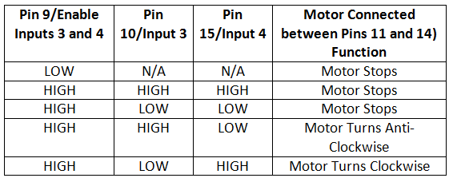

The pin 4, 5, 13 and 12 of the L298N are grounded while pin 1, 16 and 9 are connected to 5V DC and pin 8 is connected to 9V DC. The pins 15, 2, 7 and 10 of the motor driver IC are connected to pins D3, D2, D1 and D0 of Particle Photon.

**2.2 Circuit**

Once the program code is transferred to Particle Photon, it starts operating according to it. The Particle Photon should be connected to any internet hotspot via Wi-Fi. The Arduino compatible code on Photon initially sends a LOW logic at all the data pins pausing both the motors and starts fetching data from the sensors.

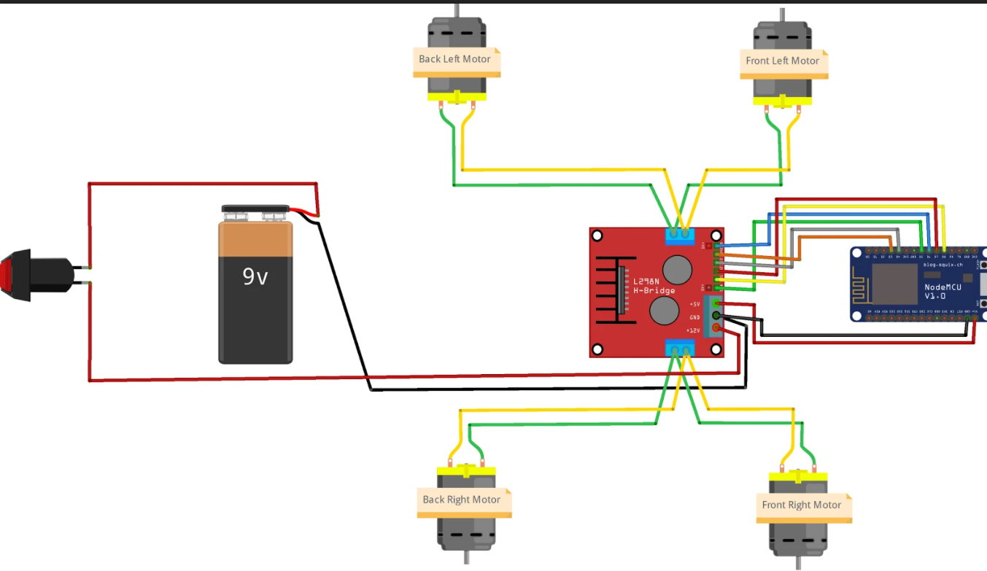

**Circuit Diagram**

The first important thing to remember is that I will be programming the ESP8266 Module through Serial Communication and also controlling the L298N Motor Driver Module.

Coming to the robot chassis, it has 4 geared motors. So, I have connected the right two motors in parallel and connected them to OUT1 and OUT2 terminals of the Motor Driver. Similarly, the left two motors to OUT3 and OUT4.

The read sensor data is passed to the Particle Cloud via Wi-Fi connection and the board waits for command to move the vehicle. The user is displayed sensor data on the webpage and have buttons to move and turn the car on the same webpage. As the user taps a button, the command in the form of string is transferred over the internet via Particle’s Cloud service. The strings are received via HTTP POST method by the Particle Photon. On detecting command, the board changes the digital logic at the data pins rotating the motors in clockwise or anti-clockwise direction.

In the robot circuit considering the two-wheel drive either front or rear possible drive, right hand side (RHS) motor is connected between pins 3 and 6 and left-hand side (LHS) motor is connected between pin 11 and 14 of the L298N. The RHS motor is controlled by pin 2 and 7 of the L293D while LHS motor is controlled by pin 10 and 15 of L293D. Hence, to move robot in different direction following digital outputs are required at the L298N pins:

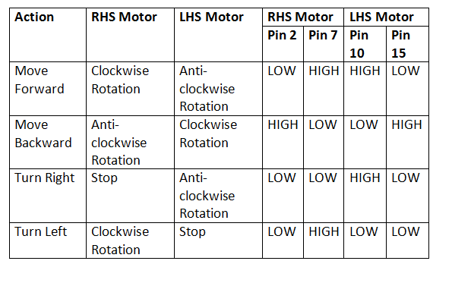

Logic Table of L298N Motor Driver IC for IOT Photon Based Robotic Car

So, to drive robot forward in this two-wheel drive, RHS motor needs to be rotated clockwise and LHS motor needs to be rotated anticlockwise. This is done by passing LOW signals to pin 2 and 15 of L298N and HIGH signal to pin 7 and 10 of L298N according to the truth table. To drive robot backward (applicable to two-wheel drive) RHS motor needs to be rotated anti-clockwise and LHS motor needs to be rotated clockwise. This is done by passing LOW signals to pin 7 and 10 of L293D and HIGH signal to pin 2 and 15 of L298N according to the truth table.

To turn the robot right, RHS motor has to be stopped and LHS motor needs to be rotated anti-clockwise. This is done by passing LOW signals to pin 2, 7 and 15 of L298N and HIGH signal to pin 10 of L298N according to the truth table. To turn the robot left, LHS motor has to be stopped and RHS motor needs to be rotated in clockwise direction. This is done by passing LOW signals to pin 2, 10 and 15 of L293D and HIGH signal to pin 7 of L298N according to the truth table. The motors are stopped in the project by giving both control inputs of L298N for each motor a LOW logic.

**USE of the project**

Robot car controlled by Wi-Fi will make our work much easier as we can make the robot do any work, we need by just a single movement on our mobile phone on computer. In near future we can see such designs getting too common and being used extensively for household purposes.

Remote control vehicles are used in law enforcement and military engagements. Remote controlled vehicles are used by many police department bomb-squads to defuse or detonate explosives.

We use Robot car at parking service to give direction to vehicle where parking space is free to park car and also check negative or danger activity in parking zone.

Robot car is used for force for spying activity. The majority y robots are tele-operated and not equipped with weapons; they are used for reconnaissance, surveillance, sniper detection, neutralizing explosive devices, etc. Current robots that are equipped with weapons are tele-operated so they are not capable of taking lives autonomously.

This robot car can also be used to push the objects from one place to another. This project will be enhanced with better Wi-Fi which would enable long distance communication. A robot is a machine designed to execute one or more tasks repeatedly, with speed and precision.

The robotic car here is equipped with a surveillance camera which enables the user to be aware of the motion of the car and the environment in which the car is being operated.

**SCREENSHOT**

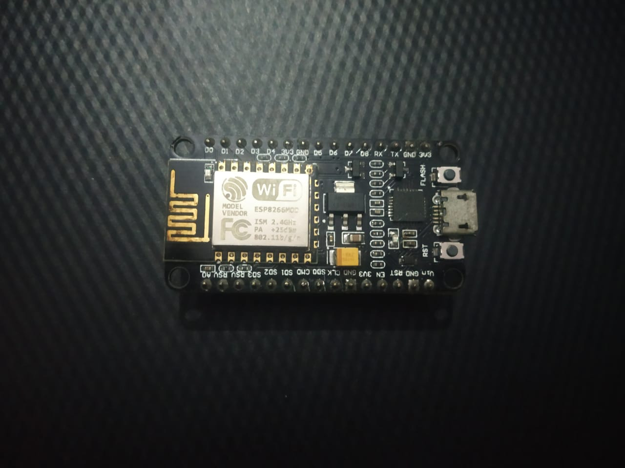

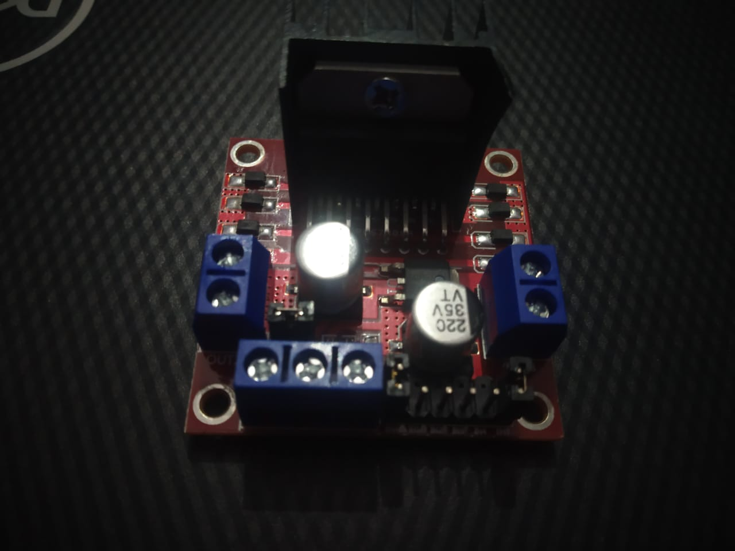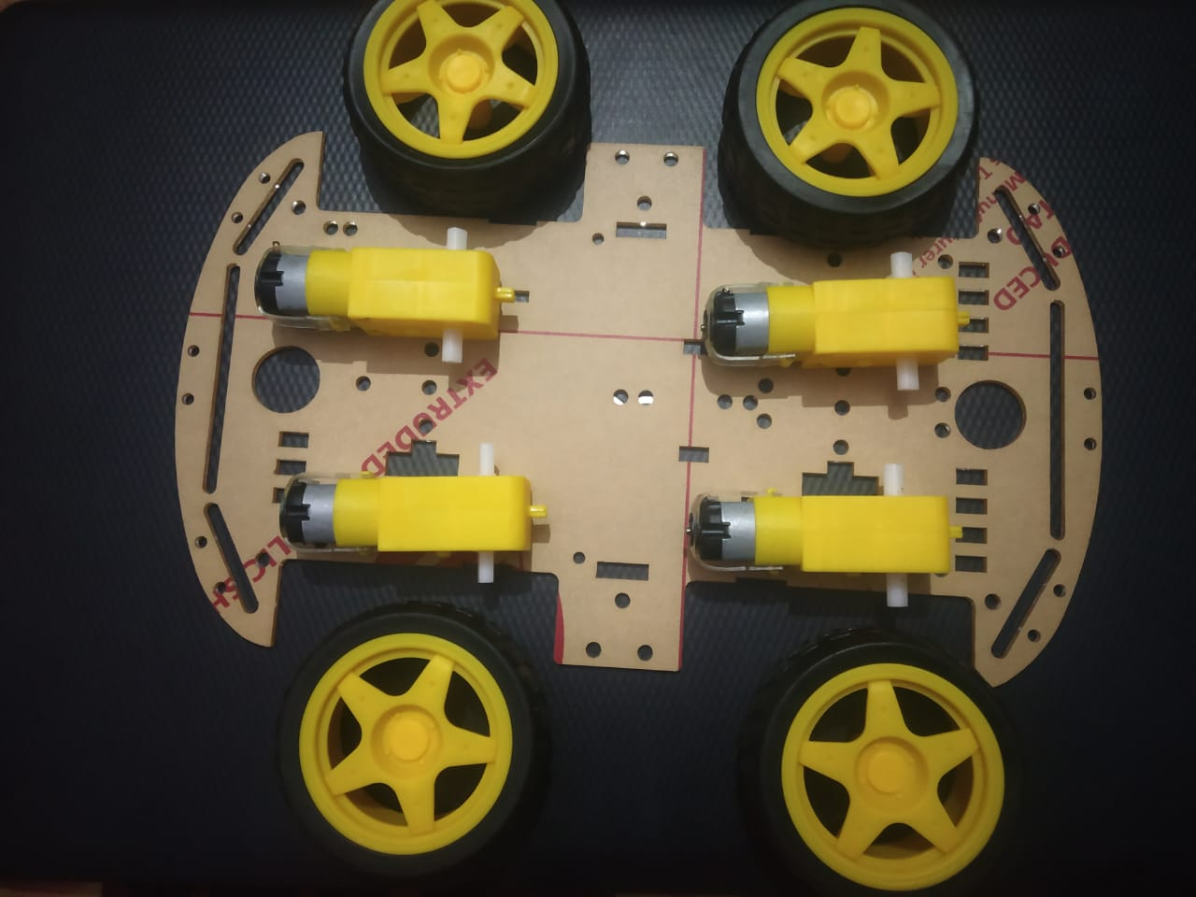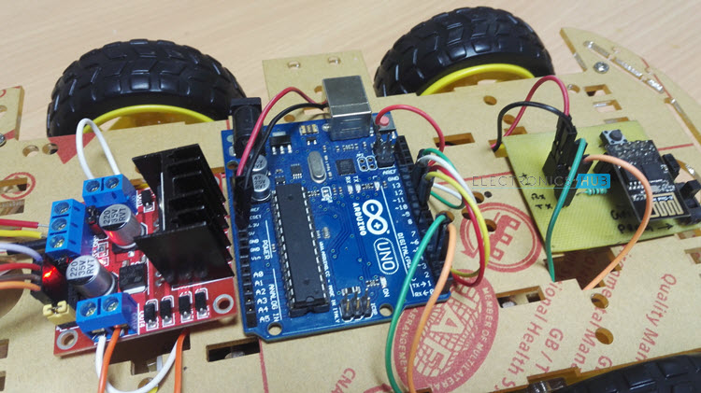

**Source Code**

#define BLYNK_PRINT Serial

#define ENA 14

#define ENB 12

#define IN_1 15

#define IN_2 13

#define IN_3 2

#define IN_4 0

#include <ESP8266WiFi.h>

#include <BlynkSimpleEsp8266.h>

char auth[]= "rzEVcDLthGmx2iHlMi2rVyD89ig7yg8S";

char ssid[] = "Airtel_925*****";

char pass[] = "air75339";

BLYNK_WRITE(V1)

{

int x = param[0].asInt();

int y = param[1].asInt();

Serial.print("X = ");

Serial.print(x);

Serial.print("Y = ");

Serial.println(y);

if (y>350)

{

Serial.print("forward");

forward();

}

if (y<170)

{

Serial.print("backward");

backward();

}

if (x<132)

{

Serial.print("left");

left();

}

if (x>380)

{

Serial.print("right");

right();

}

if ((y==256) && (x==256))

{

Serial.print("stop");

stop();

}

}

void setup() {

pinMode(ENA, OUTPUT);

pinMode(ENB, OUTPUT);

pinMode(IN_1, OUTPUT);

pinMode(IN_2, OUTPUT);

pinMode(IN_3, OUTPUT);

pinMode(IN_4, OUTPUT);

Serial.begin(115200);

Blynk.begin(auth, ssid, pass);

}

void loop()

{

Blynk.run();

}

void forward(){

digitalWrite(IN_1, LOW);

digitalWrite(IN_2, HIGH);

digitalWrite(IN_3, LOW);

digitalWrite(IN_4, HIGH);

}

void backward(){

digitalWrite(IN_1, HIGH);

digitalWrite(IN_2, LOW);

digitalWrite(IN_3, HIGH);

digitalWrite(IN_4, LOW);

}

void right(){

digitalWrite(IN_1, HIGH);

digitalWrite(IN_2, LOW);

digitalWrite(IN_3, LOW);

digitalWrite(IN_4, HIGH);

}

void left(){

digitalWrite(IN_1, LOW);

digitalWrite(IN_2, HIGH);

digitalWrite(IN_3, HIGH);

digitalWrite(IN_4, LOW);

}

void stop(){

digitalWrite(IN_1, LOW);

digitalWrite(IN_2, LOW);

digitalWrite(IN_3, LOW);

digitalWrite(IN_4, LOW);

}

**Conclusion**

Research groups are modifying the previously designed robots for new purposes and different aspects. We started our work from zero. However, our collaboration, hardworking, skills, and ambition gave us the power of doing best work. Our best understanding and combine searches on parallel fields helped us to accomplish our work correctly. Now we can say that we can do more efficient work and can perform more difficult task easier. Our idea is mainly for army use. The army is doing researches on this type of ideas and doing their lab works to build a capable working robot. It will replace the humans and will save many lives in critical situations. We are very hopeful with our idea that it will bring a significant change in our technical field and our minds

***THANK YOU***